Retail Sales Data Agent

Name: Phathutshedzo
Surname:Mpfumali
Student number :2805001455
Date:23-05-2026

Introduction & Objective

This project was about building a working Data Agent on Databricks that answers business questions about a real retail sales dataset, the agent helps a business user, manager, or CEO ask questions about a shop's sales performance and receive useful business insights. The reason why I complete the this project was to learn more and understand how data agent works and how it help a business user to analyse their business’s performance .

01: UPLOAD THE DATASET
Screenshot of the uploaded dataset, the preview, and the file location
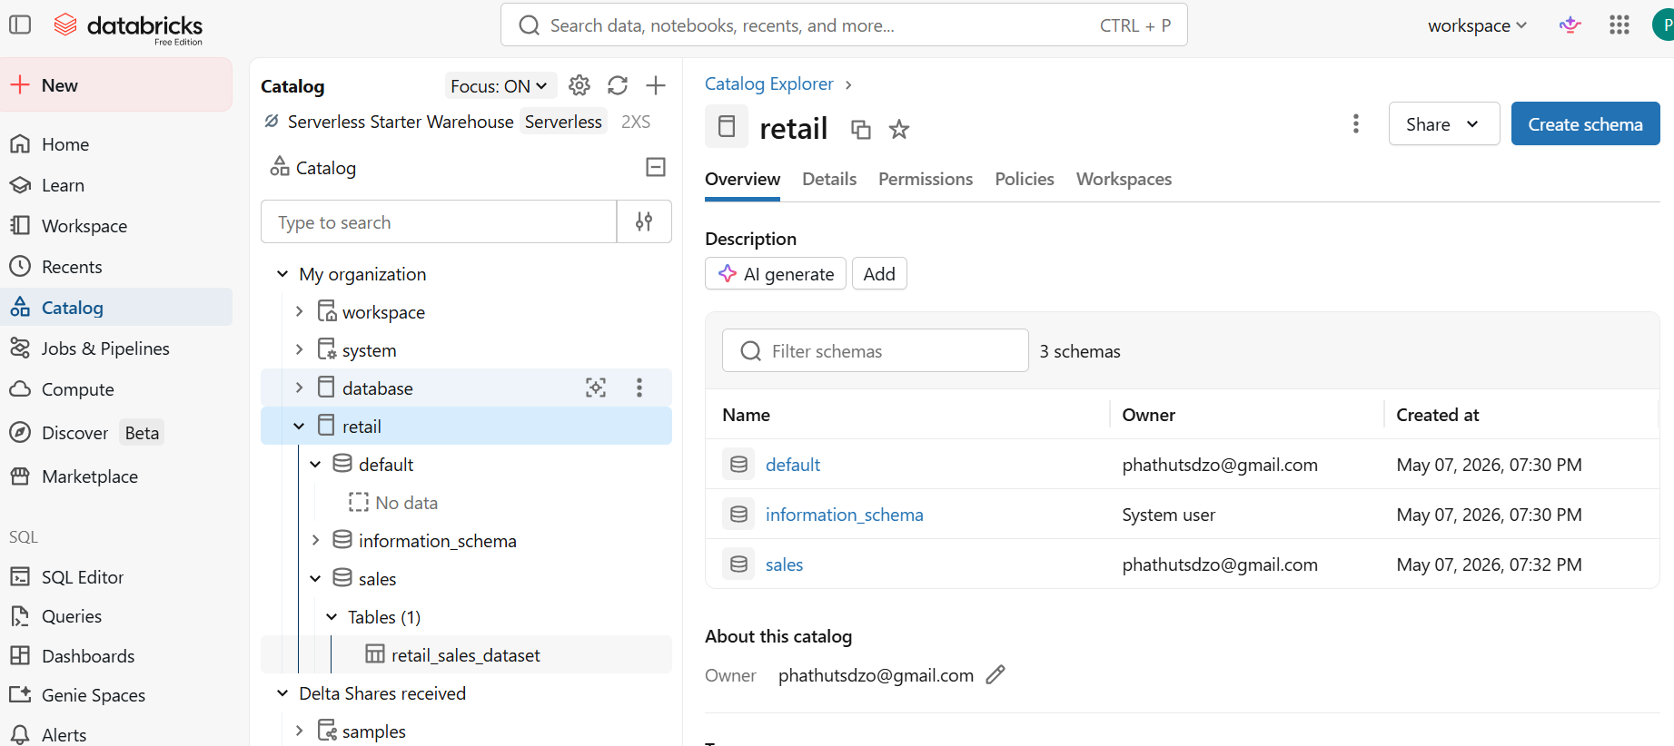
02: REVIEW THE DATASET
Screenshot of the preview, the column list, and any summary view.
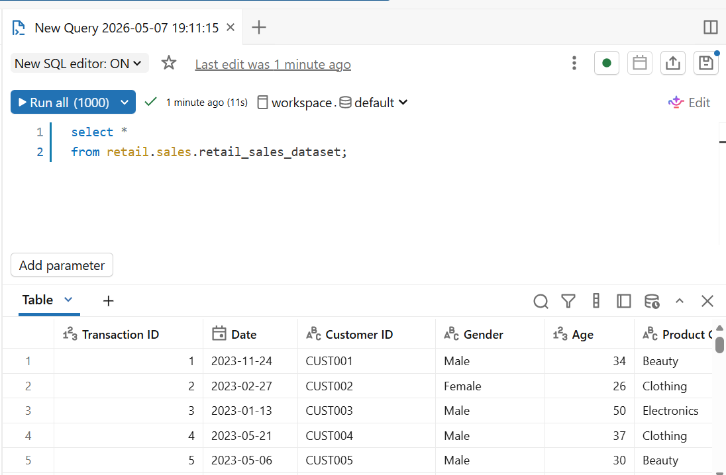
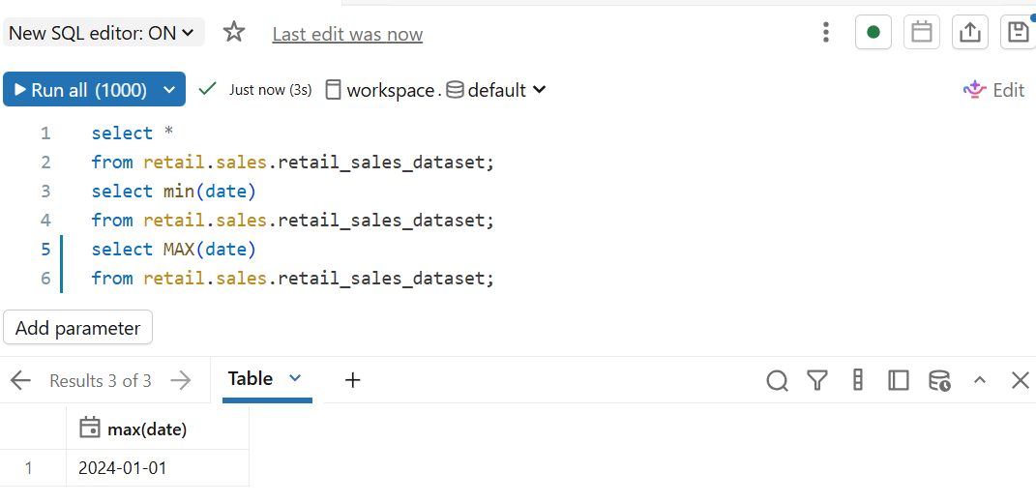
03: PREPARE THE TABLE
Screenshot of the table, its description, and the columns.
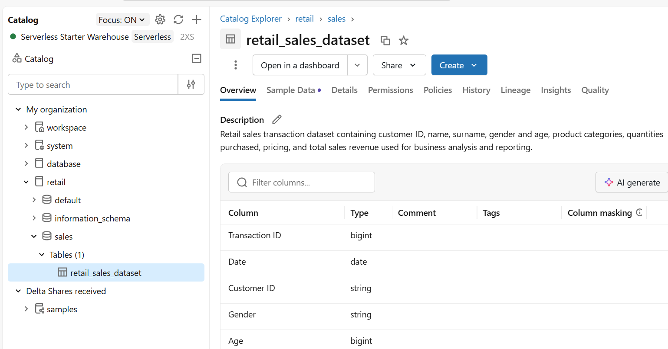
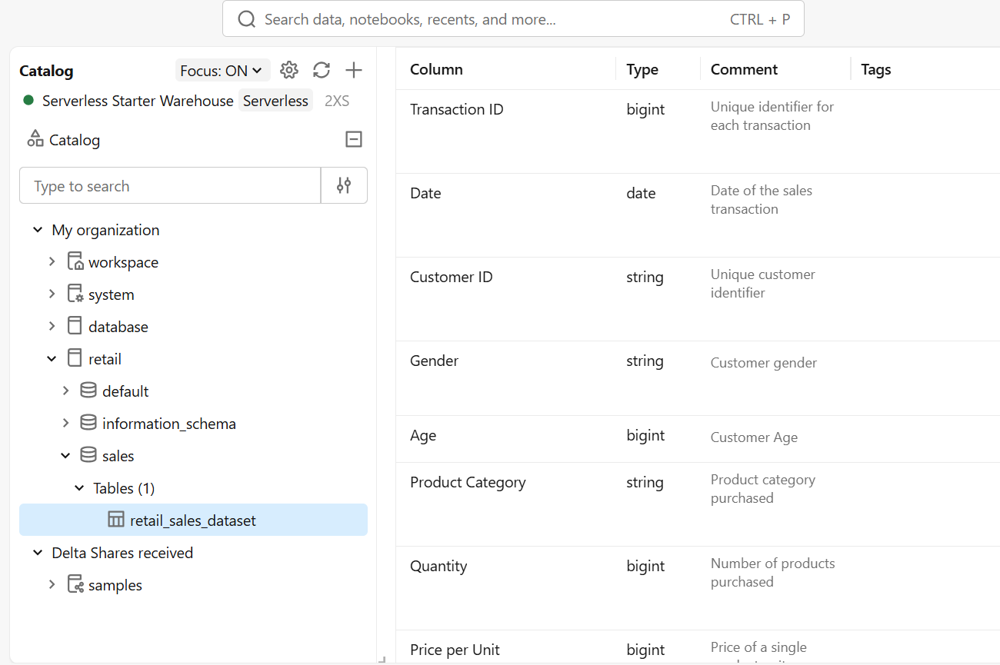
4: Create the Data Agent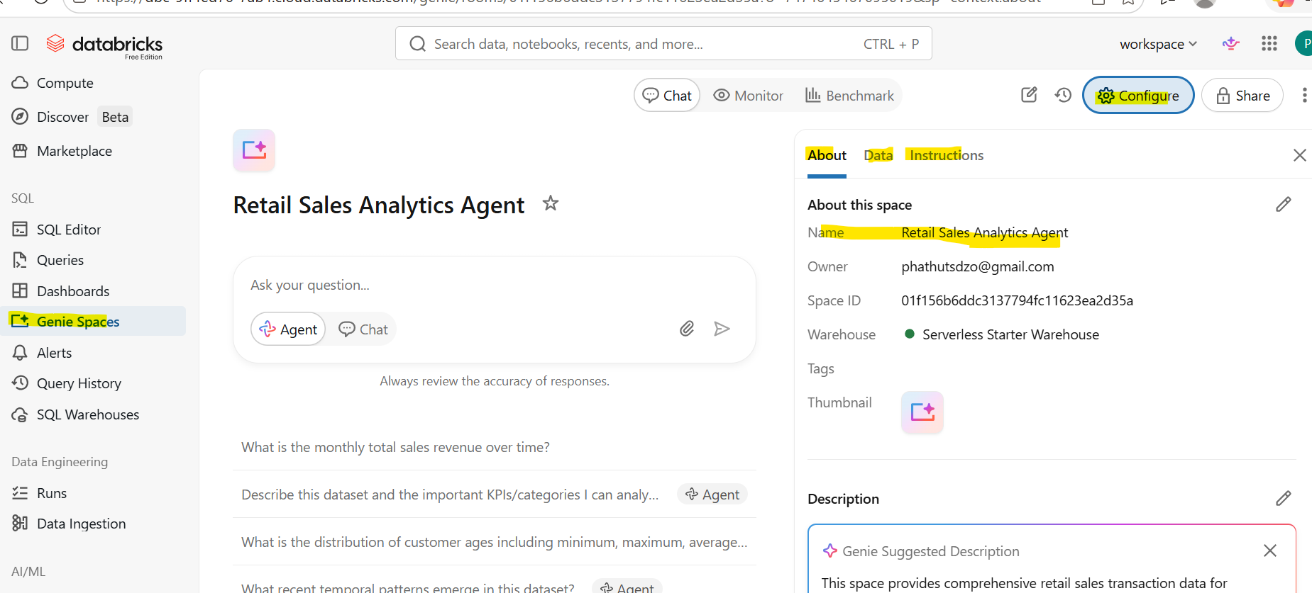 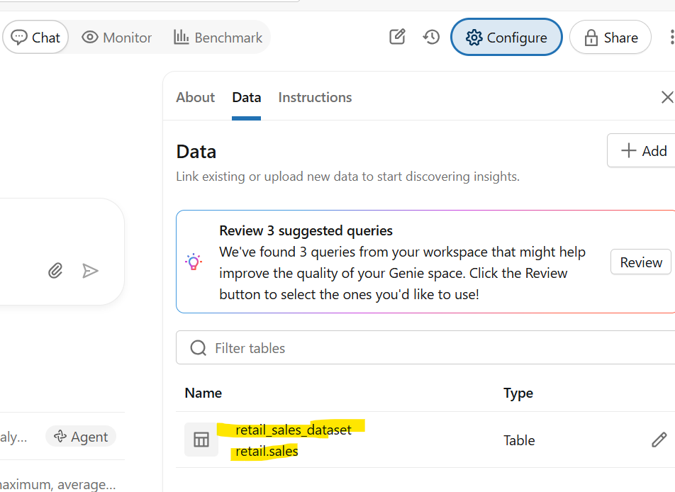
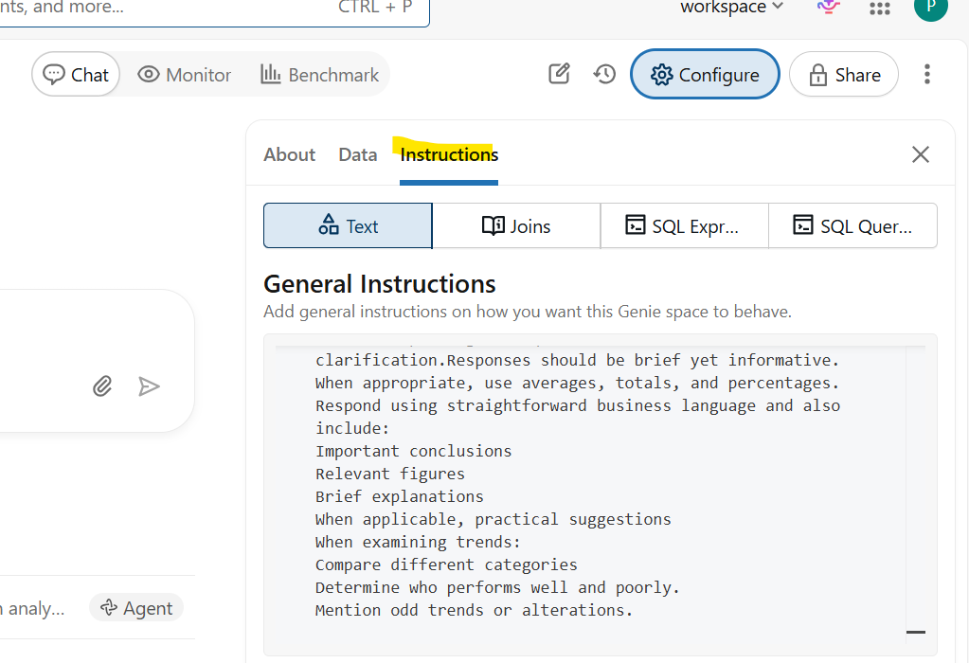
Testing connectivity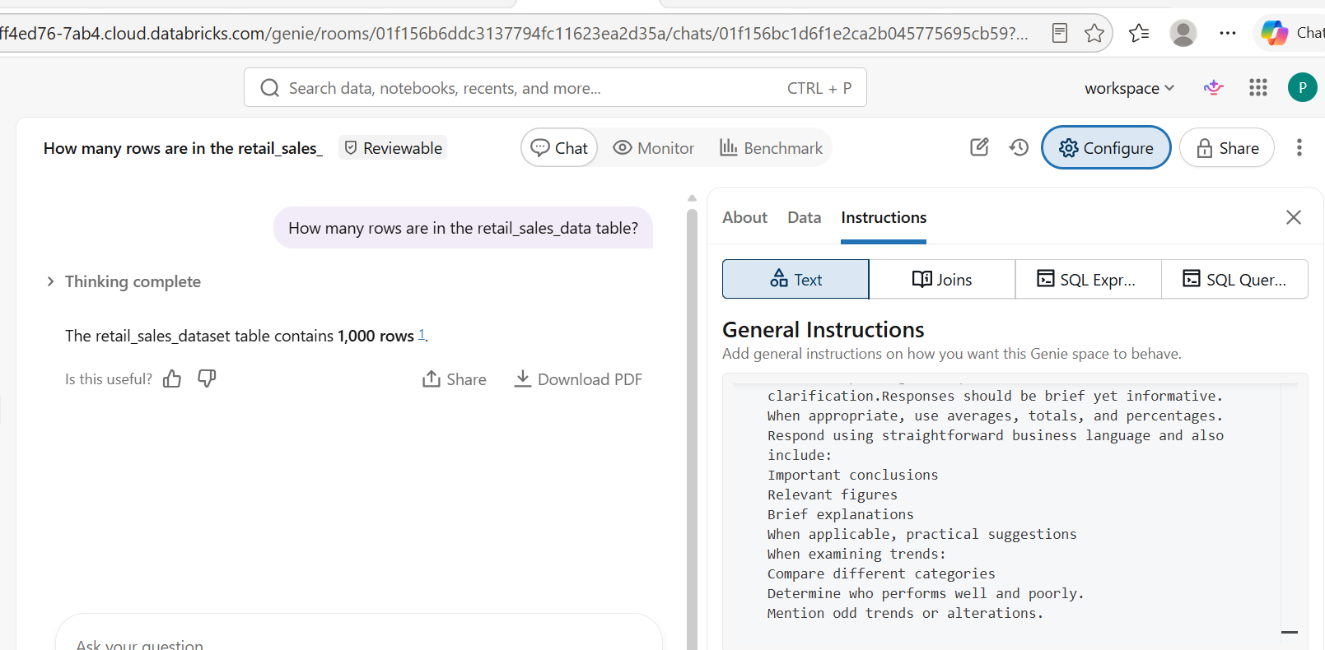

5: Full agent instructions
You are designed to help store managers, business owners and CEO's understand retail performance using the retail_sales_data dataset, do not create your own trends, categories, or numbers.It is your responsibility to respond to questions using the data from the retail_sales_dataset table regarding:
- The performance of sales
- Analysis on a monthly and category basis
- Consumer behavior
- Patterns of revenue
- Trends in products
Before responding to a question that is not clear, seek clarification. Responses should be brief yet informative.When appropriate, use averages, totals, and percentages.Respond using straightforward business language and also include:
- Important conclusions
- Relevant figures
- Brief explanations
- When applicable, practical suggestions
When examining trends:
Compare different categories
Determine who performs well and poorly.
Mention odd trends or alterations.
6: 10 QUESTIONS
1What is the total sales revenue?
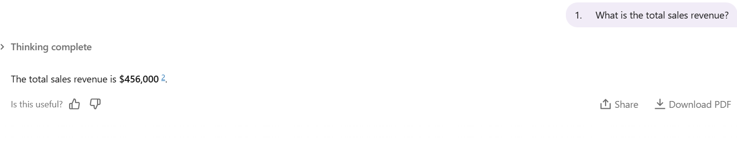
2.Which product category generated the highest revenue?
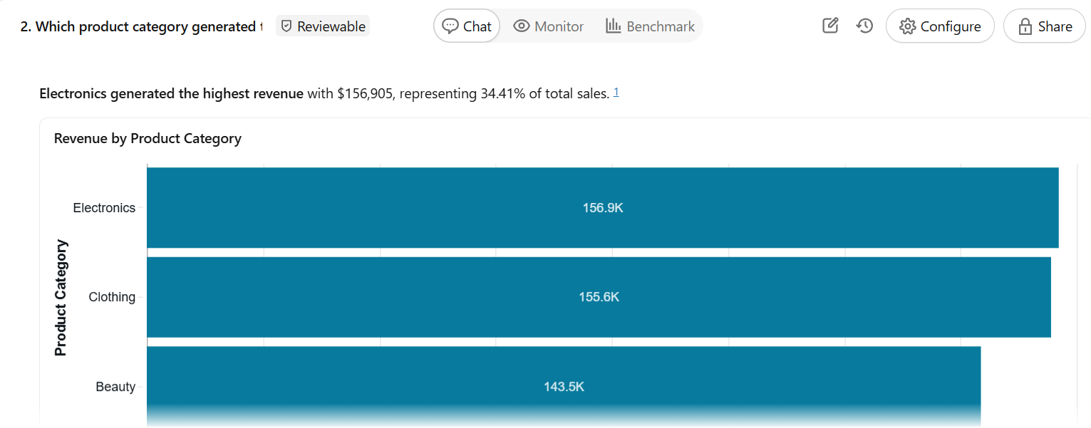
3.Which month had the highest sales?
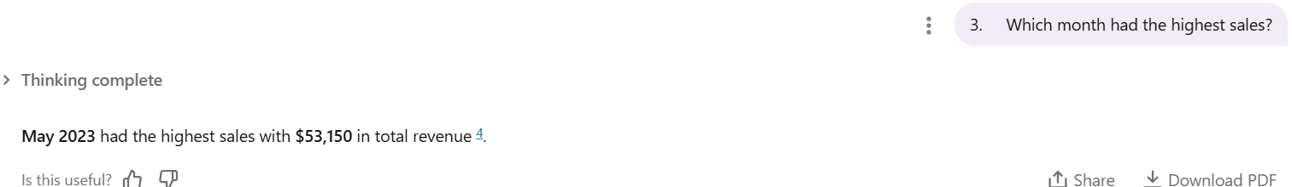
4.What is the average transaction value?
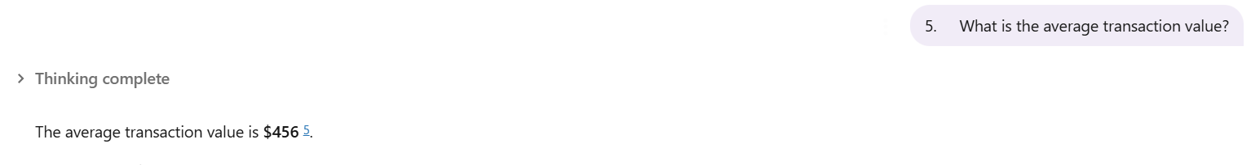
5.Which gender spends more on average?
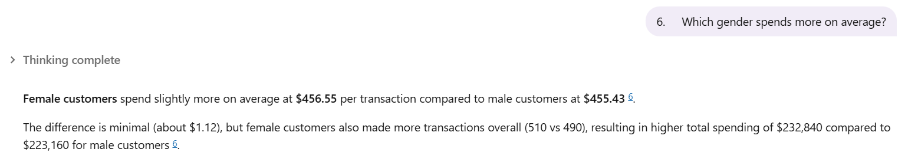
6.Which age group purchases the most products?
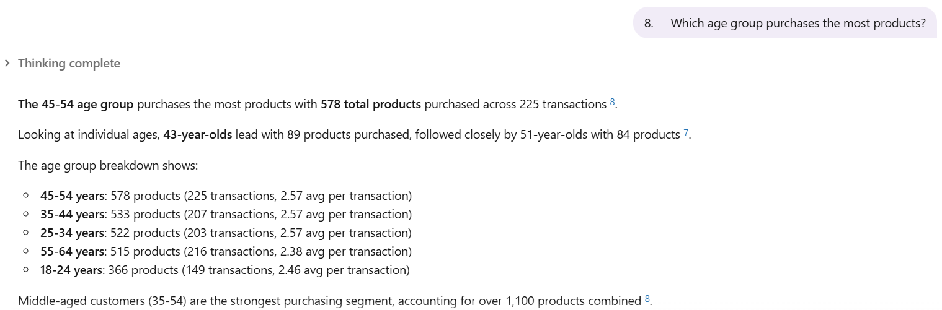
7.What are the top 5 customers by spending?
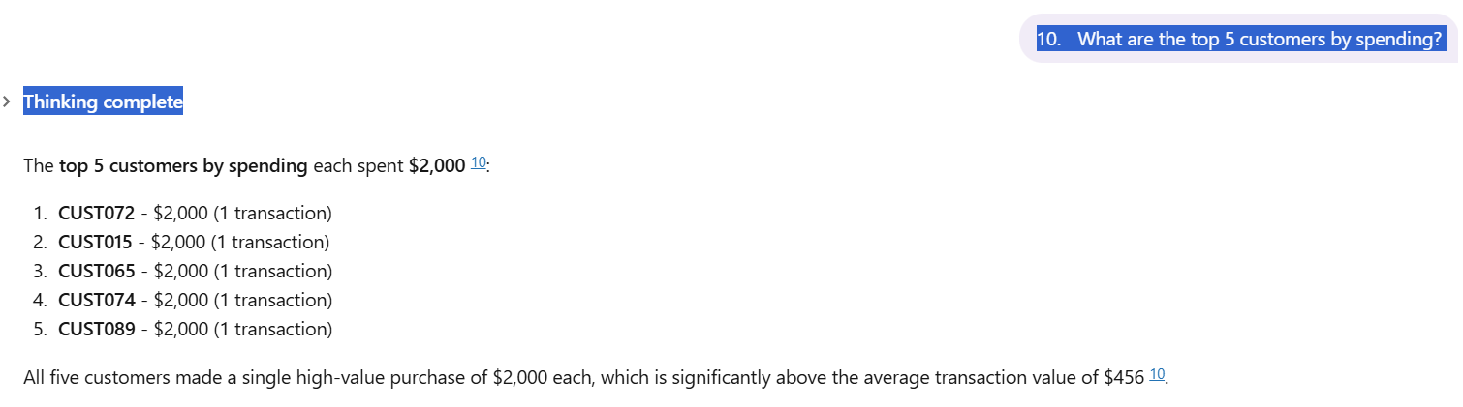
8.Which product category did not performs well?
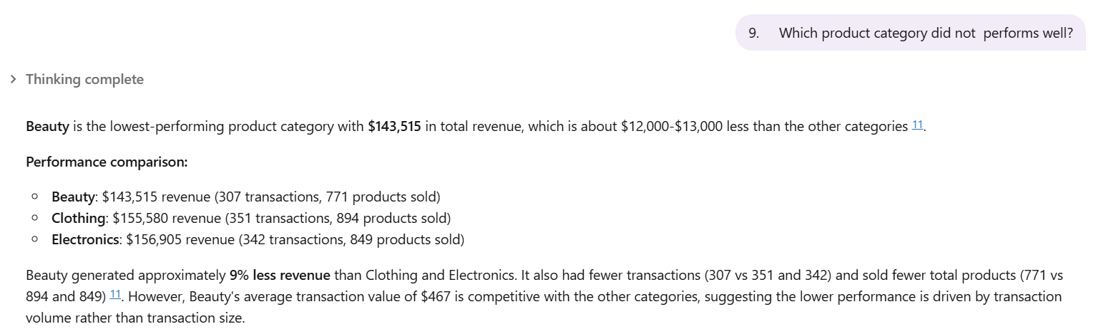

9.Which category is most popular among customers under 30?
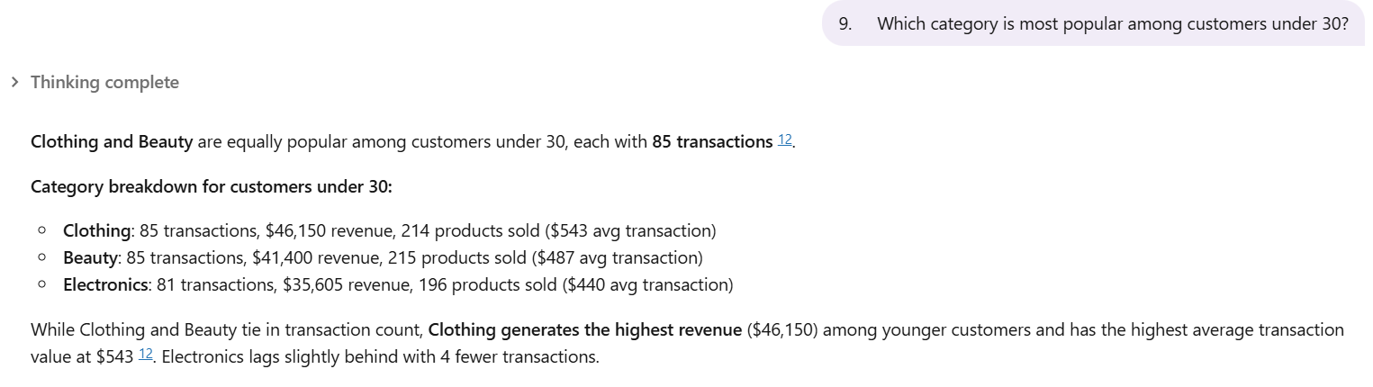
10.Are there any noticeable monthly sales trend
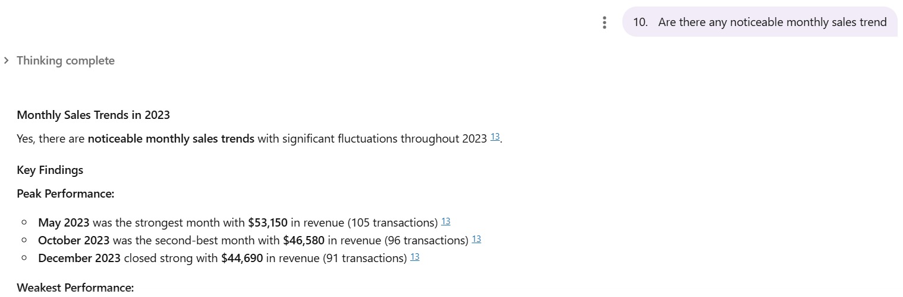
7: Validating the Answers
1.Which product category generated the highest revenue?

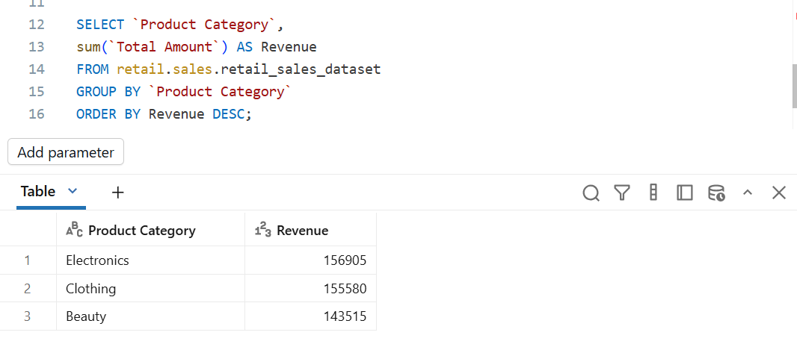

2 What is the total sales revenue?
Below answer is correct , its just the sum of all the amount
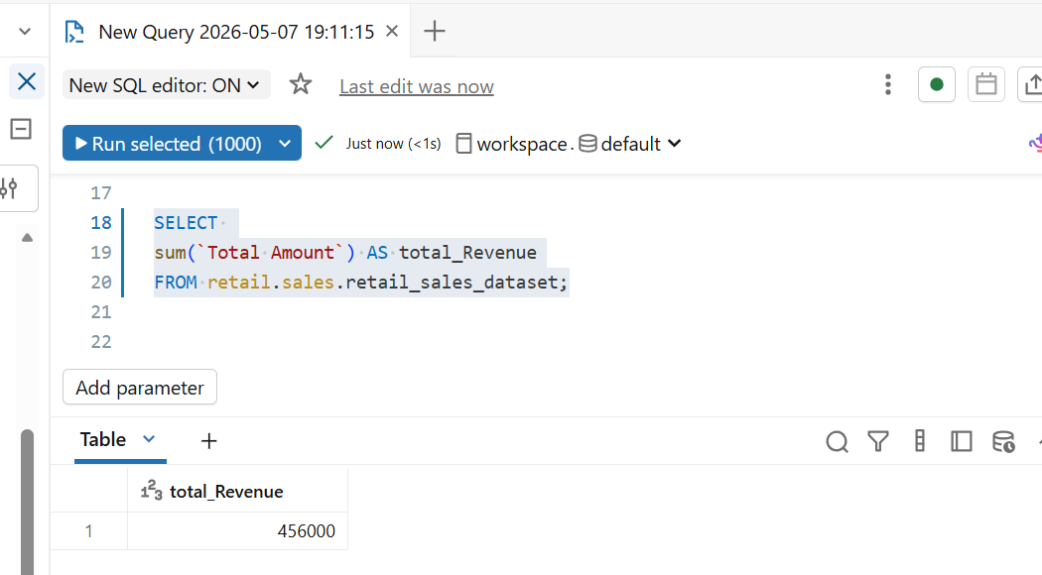

3.What is the average transaction value?
Below answer is correct , to find the average is the sum of total amount divide by the number of rows ( 456000/1000= 456)
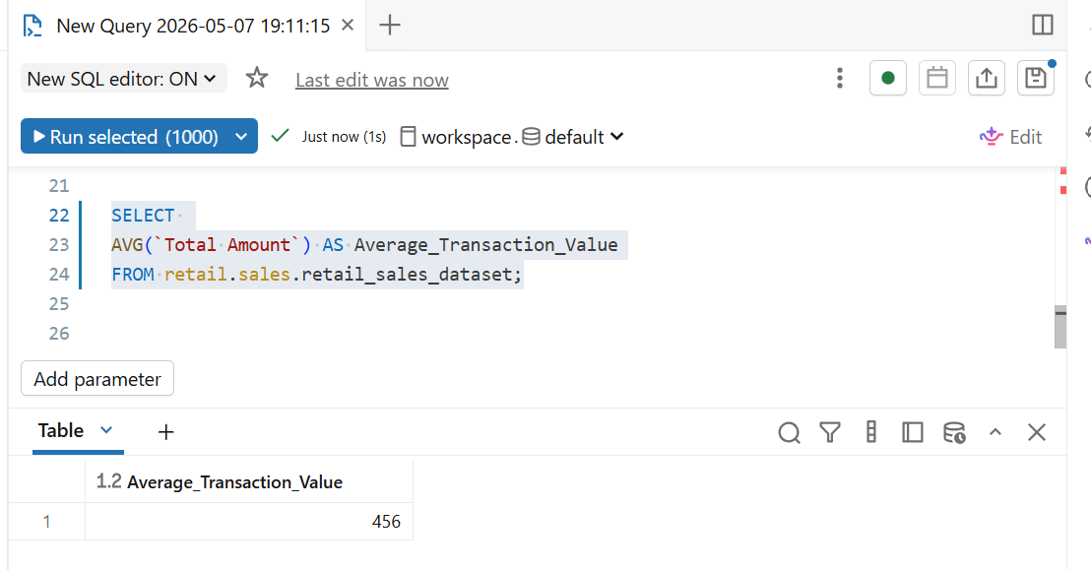

Key insights- The agent reveals that the shop only perform better in May, October and December out of twelve months im 2023 which is in overall poor performance , this suggests the business may depend heavily on seasonal demand and lacks consistent customer activity throughout the year.
Business recommendation:
1.During weaker months to attract more customers and increase sales volume,The business should introduce:
- Discounts
- Combo deals
- Loyalty rewards
2. The company should strengthen marketing during slow months using:
- Social media campaigns
- WhatsApp promotions
- Email marketing
- Influencer partnerships
This helps keep customers engaged throughout the year instead of only during peak seasons.
Conclusion
Creating agent instructions was the hard, but after testing some of the questions, I’m confidence that my instructions worked

GitHub repository link: phathutsdzo-commits/Retail-Sales-Data-Agent-: This project was about building a working Data Agent on Databricks that answers business questions about a real retail sales dataset, the agent helps a business user, manager, or CEO ask questions about a shop's sales performance and receive useful business insights.

